Zi Shiying Tang Soo Do Present: 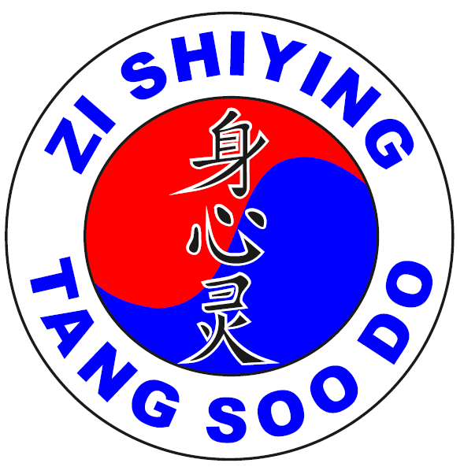
WARRIORS ASSEMBLE – Invitational Championships 2024
Queens Campus Sports Centre
Stockton-on-Tees, TS17 6BH
Saturday 27th April 2024 from 9:00am to 4:00pm
INDIVIDUAL COMPETITION ENTRY APPLICATION AND RELEASE FORM
Please complete this application form and return it to your instructor. All forms need to be submitted to Master Craig Moat by 1st March 2024
If you have ANY questions, please ask your instructor for help and please, PRINT clearly
Last Name ……………………….........…..…….................…… First Name ………...............…………………..........
Gender ….........…… Age ….......….… Gup Rank …........... or Dan Rank…...............
Height ………………….. (CMS) Weight………………… (KG)
Address ……………………………………………………………………………………………………………………………………………….…
Phone …............………...……….………. E-mail address …………...............................……………………………………….
Club Name ……………………………………...........……..…… Instructor Name………….........................……………
Entry fee = £0 (This championship is completely FREE)
All we ask is all persons entering the hall both competitors & spectators bring some dried/tinned food and/or toiletries, so that we can donate it to a local foodbank
Below please tick what you will be competing in:
Traditional Hyungs ( )
Weapons ( )
Semi Contact, Free Fighting ( )

Note: Sparring equipment for semi-contact including gum shield is mandatory & will not be
supplied
Release of Liability:
In consideration of being allowed to participate in any way in the Zi Shiying Tang Soo Do Championships, the undersigned, the parent or
guardian of a minor child participant:
1. Agrees to inspect, prior to participation, the facilities and equipment to be used, and if the participant believes anything is unsafe, he or she should immediately withdraw from competition and refuse to participate.
2. Acknowledge and fully understand that each participant will be engaging in activities that involve risk of serious injury, including permanent injury and death, and severe social and economical losses which might result not only from their actions, inaction or negligence, but the action, inaction or negligence of others, the rules of play or the condition of the premises, or any equipment used. Further that there may be other risks not known to us or not reasonably foreseeable at this time.
3. Assume all the foregoing risk, and accept personal responsibility for the dangers following such injury, permanent disability, or death.
4. Released, waive, discharge, and covenant not to sue Zi Shiying Tang Soo Do UK, the Sports Centre any and all
sponsors, officials, promoters, instructors, or other participants, all of which are hereinafter referred to as “releases”, from any and all liability to each of the undersigned, his or her heirs and next of kin for any and all claims, demands, losses, damages on account of injury, including death or damage to property,
caused or alleged to be caused in whole or in part by the negligence of the releases or otherwise.
WE HAVE READ THE ABOVE WAIVER AND RELEASE, UNDERSTAND THAT WE HAVE GIVEN UP SUBSTANTIAL RIGHTS BY
SIGNING IT AND SIGN IT VOLUNTARILY:

Date …………............…............…Signature of Participant/guardian……....………………………………………………………..
Please give completed entry forms to your instructor who will email them to Master Craig Moat when all of their students have completed them
Zi Shiying Tang Soo Do Invitational Championships
General Rules
HYUNG SCORING PROCEDURE
1. Scoring system: 7 points (lowest score for gup grades) 8 points (Lowest score for DAN grades) up to 10 points (highest score).
2. There will be a minimum of 3 judges (from mixed clubs to ensure fair judging) for each ring.
3. Each judge will issue points according to the 7—10 or 8-10 point scoring system with increments of 0.1.
4. All scores from each of the 3 judges will be added together to determine a total for each
competitor and then divided by three to give the average score. When there are 5 judges or more the highest and lowest scores will be discounted and an average will be taken of the remaining scores.
5. In the event of a tie, the contestants will be asked to perform another hyung of their own choice. If this results in another tie the contestants will be asked to perform a different hyung relevant to their grade, this hyung will be chosen by a senior judge.
6. All hyungs performed must be part of the agreed syllabus within your club or association
which your Master or Instructor teaches you, no hyungs created by individuals are permitted
to ensure fair and consistent judging.
HYUNGS COMPETITION REQUIREMENTS
Competitors will be required to perform traditional hyung’s during the Championships. Chil Sung hyungs will be allowed.
All hyungs must be performed in line with the competitor’s rank which is in line with your club which your instructor teaches you at that rank. You will be down marked for doing a higher hyung than your rank. e.g Red belt performing a black belt form will be down marked.
FREE SPARRING
GENERAL INFORMATION AND REQUIREMENTS
1. There will be absolutely no jewellery worn during free sparring.
2. Fingernails and toenails will be cut to ensure no cutting or scratching of the opponent due to jagged or long nails.
3. Gum shields, protective groin guards, headgear and safety hand and foot pads are
mandatory. NO UFC style hand mitts allowed. NO elasticated foot pads with just cover feet
allowed, it must be a full foot pad. If the competitor does not comply with these safety
regulations, they will not be allowed to enter this section.
SCORING SPARRING COMPETITION
1. There are 4 judges which will be sat in each corner of the ring. 1 Referee will be located in the ring with the competitors at all time and is in full control of the ring.
2. There are scoreboards for both competitors RED to the right and BLUE to the left. Both competitors will have either a red or blue ribbon looped in the back of their belt and they will be stood behind their line (red to the right and blue to the left). In addition to this all Judges and the referee will all don a red wrist band on their right wrist and a blue wrist band on their left. (The referee and judges MUST roll back the cuffs on their jacket to ensure there is clear visibility of their wrist bands.
3. Judging system: Either Referee or the Judges can blow their whistle at any time if they see a point. Further to a whistle being blown the Referee will stop the bout and signal for both competitors to stand behind their line. Once this is done the referee will blow their whistle and signal their score, at this point all judges will do the same
a. 1 Point - Hand raised vertically 1 finger point
b. 2 Point - Hand raised vertically 2 finger point
c. No Point – Cross clenched fists in front of your stomach.
c. Couldn’t See - Place both hands over the eyes.
d. To Heavy Contact – Point 1 finger to the floor with wristband colour corresponding to the competitor making contact.

4. Score card
a. 1 points for controlled kick to the head
b. 1 point for controlled kick to the body
c. 1 point for controlled punch/back fist to the body
d. 1 point for controlled punch/back fist to the head
e. 2 point for controlled jump kick with both feet off the floor,
f. 2 points for blocking and counter (counter can be with a punch or kick)
g. 10 points maximum for winner, must win by two clear points
5. Fight duration will be 2 minutes, if competitors have drawn then the next point scored will
determine the winner.
6. Warnings or disqualification will be given if any of the following occur:
a. Sweeping of the competitors leg
b. Any intentional contact is given; this will result in instant disqualification.
c. Excessive contact, especially to the face e.g. which draws blood WILL lead to a
disqualification (bleeding from the nose etc.)
7. Angry and uncontrolled competitors which have had two warnings will be stopped and disqualified by the centre ring judges to prevent the opponent getting injured. You will get warnings for using unsighted techniques e.g. spinning back fist, kicks below the belt, attacks to the back or the back of the head etc..
8. Team Sparring (When applicable) – Teams of 1 lady and 3 men which must be over 18 and must be dan grades. All 4 team members will fight one fighter from the opposition team (Male v Male and Female v Female). Teams will be added to a Free fighting grid and will compete through to the final.
Let our sparring be controlled and fun! Tang Soo

